ASSIGNMENT 8  FLOW CONTROL | Name: Nivetha Dhanakoti  Reg no.: 3122 22 5001 087

Aim:
To be proficient in developing an application to simulate flow control technique using socket programming in C

Write the code using socket programming in C
1. Establish the basic connection between client and the server.
2. Develop an application to simulate flow control technique using HDLC protocol.
3. Client gets input data from user and divides them as 4 bits into a packet.
4. Add header with sequence number, source and destination address.
5. Send them to server. Before sending each packet ask whether to send or not (to create loss).
6. Server on receiving the packet and by reading the sequence number, acknowledges the client as per Go Back N Protocol.
7. If any packet is missing, based on the acknowledgement received from server, client retransmits it.
8. On Client side, before beginning new transmission, asks whether to close connection.

Sample Input and Output
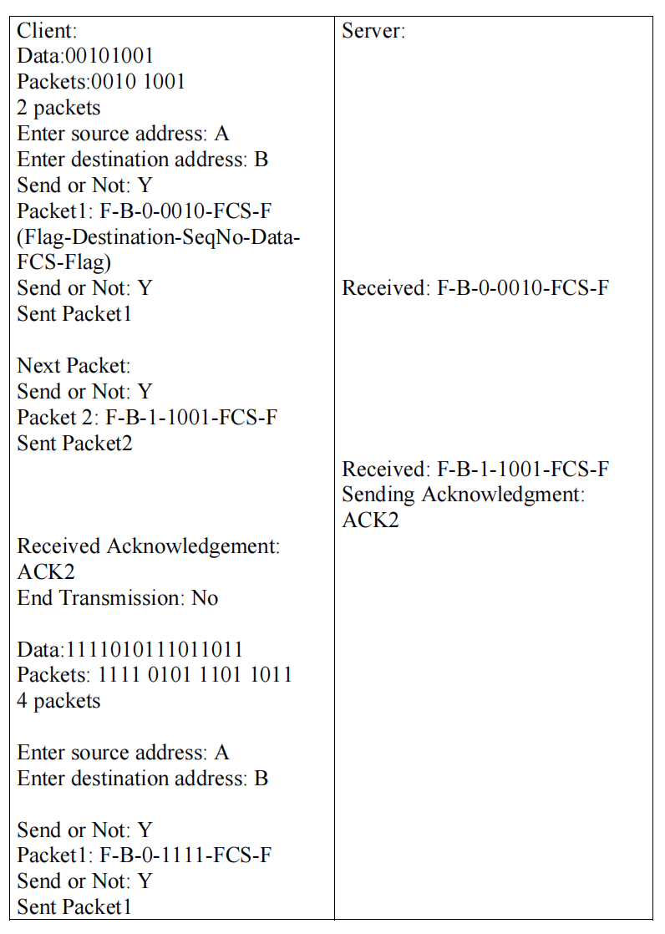
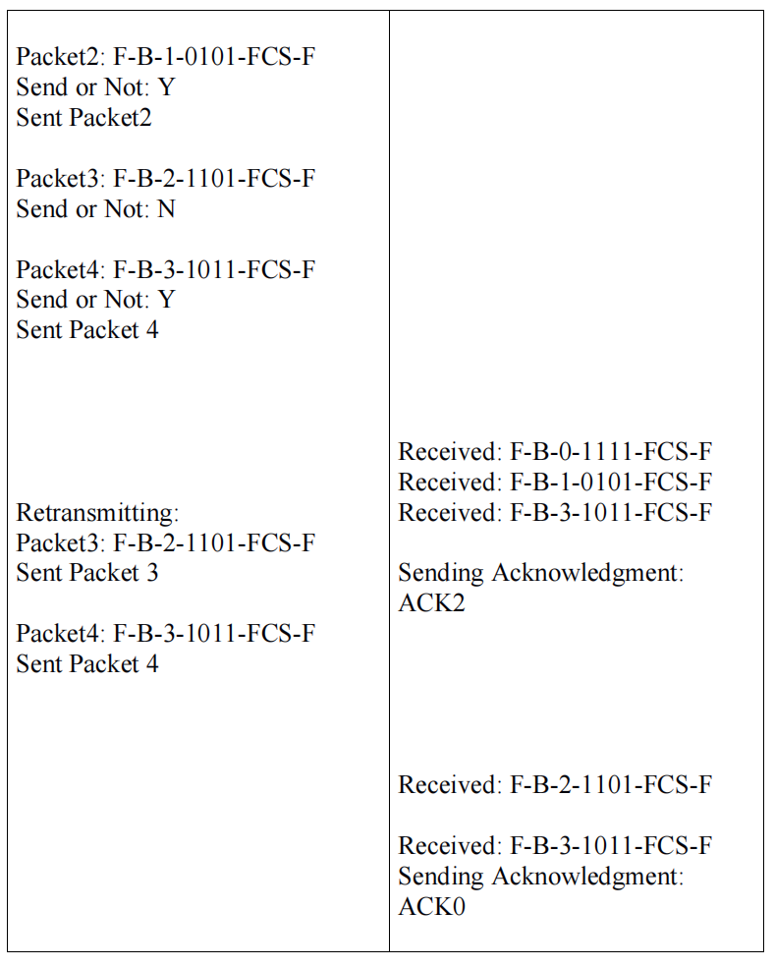
Server Code:

#include <stdio.h>
#include <stdlib.h>
#include <string.h>
#include <unistd.h>
#include <arpa/inet.h>

#define PORT 8888

// Function to send an acknowledgment
void send_acknowledgment(int new_socket, int seq_num) {
char ack[10];
sprintf(ack, "ACK%d", seq_num);
send(new_socket, ack, strlen(ack), 0);
printf("Sending Acknowledgment: %s\n", ack);
}

int main() {
int server_fd, new_socket;
struct sockaddr_in address;
int addrlen = sizeof(address);
char buffer[1024] = {0};

// Create socket
if ((server_fd = socket(AF_INET, SOCK_STREAM, 0)) == 0) {
perror("socket failed");
exit(EXIT_FAILURE);
}

// Bind the socket to the port
address.sin_family = AF_INET;
address.sin_addr.s_addr = INADDR_ANY;
address.sin_port = htons(PORT);

if (bind(server_fd, (struct sockaddr *)&address, sizeof(address)) < 0) {
perror("bind failed");
exit(EXIT_FAILURE);
}

// Listen for incoming connections
if (listen(server_fd, 3) < 0) {
perror("listen");
exit(EXIT_FAILURE);
}

// Accept the connection from the client
if ((new_socket = accept(server_fd, (struct sockaddr *)&address, (socklen_t*)&addrlen)) < 0) {
perror("accept");
exit(EXIT_FAILURE);
}

while (1) {
// Clear the buffer before reading
memset(buffer, 0, sizeof(buffer));

// Read the data sent by the client
int valread = read(new_socket, buffer, sizeof(buffer));
if (valread > 0) {
printf("\nReceived: %s\n", buffer);

// Extract sequence number from the packet (assuming the sequence number is in the correct position)
char seq_num = buffer[6] - '0';

// Send an acknowledgment for the received packet
send_acknowledgment(new_socket, seq_num);
} else if (valread == 0) {
printf("\nConnection closed by client.\n");
break;
} else {
perror("recv");
}
}

close(new_socket);
close(server_fd);
return 0;
}

Client Code:
#include <stdio.h>
#include <stdlib.h>
#include <string.h>
#include <unistd.h>
#include <arpa/inet.h>

#define PORT 8888

// Function to send a packet with flow control
int send_packet(int sock, char* packet, int seq_num) {
char buffer[1024] = {0};

printf("\nPacket%d: %s\n", seq_num, packet);
char decision;
printf("Send or Not (Y/N): ");
scanf(" %c", &decision);

if (decision == 'Y' || decision == 'y') {
send(sock, packet, strlen(packet), 0);
printf("Sent Packet%d\n", seq_num);
read(sock, buffer, sizeof(buffer));
printf("Received Acknowledgement: %s\n", buffer);
return 1; // Packet was sent successfully
} else {
return 0; // Packet was not sent
}
}

// Function to create a packet with sequence number, source, destination, and data
void create_packet(char* packet, char* src_addr, char* dest_addr, int seq_num, char* data) {
sprintf(packet, "F-%s-%d-%s-FCS-F", dest_addr, seq_num, data);
}

int main() {
int sock = 0;
struct sockaddr_in serv_addr;
char data[1024];
char src_addr[10], dest_addr[10];
int packets_sent[100] = {0}; // Keep track of sent packets, 0 = not sent, 1 = sent

// Create socket
if ((sock = socket(AF_INET, SOCK_STREAM, 0)) < 0) {
printf("\n Socket creation error \n");
return -1;
}

serv_addr.sin_family = AF_INET;
serv_addr.sin_port = htons(PORT);

// Convert IPv4 and IPv6 addresses from text to binary form
if (inet_pton(AF_INET, "127.0.0.1", &serv_addr.sin_addr) <= 0) {
printf("\nInvalid address/ Address not supported \n");
return -1;
}

// Connect to the server
if (connect(sock, (struct sockaddr *)&serv_addr, sizeof(serv_addr)) < 0) {
printf("\nConnection Failed \n");
return -1;
}

while (1) {
printf("\nData: ");
scanf("%s", data);

int len = strlen(data);
int total_packets = (len + 3) / 4; // Calculate number of 4-bit packets

printf("\nPackets: ");
for (int i = 0; i < len; i += 4) {
for (int j = i; j < i + 4 && j < len; ++j) {
printf("%c", data[j]);
}
printf(" ");
}
printf("\n%d packets\n", total_packets);

printf("Enter source address: ");
scanf("%s", src_addr);

printf("Enter destination address: ");
scanf("%s", dest_addr);

// Send packets
for (int i = 0; i < total_packets; i++) {
if (packets_sent[i] == 0) { // Only send packets that haven't been sent
char packet[1024] = {0};
char chunk[5] = {0};

strncpy(chunk, &data[i * 4], 4); // Extract 4-bit chunk
create_packet(packet, src_addr, dest_addr, i, chunk);

if (send_packet(sock, packet, i)) {
packets_sent[i] = 1; // Mark packet as sent
}
}
}

// Retransmit unsent packets if any
for (int i = 0; i < total_packets; i++) {
if (packets_sent[i] == 0) { // Check for unsent packets
printf("\nRetransmitting:\n");
char packet[1024] = {0};
char chunk[5] = {0};

strncpy(chunk, &data[i * 4], 4); // Extract 4-bit chunk
create_packet(packet, src_addr, dest_addr, i, chunk);

send_packet(sock, packet, i); // Attempt to resend
}
}

char end_transmission[5];
printf("\nEnd Transmission (Yes/No): ");
scanf("%s", end_transmission);

if (strcmp(end_transmission, "Yes") == 0 || strcmp(end_transmission, "yes") == 0) {
close(sock);
printf("Transmission Ended\n");
break;
}

// Clear buffer for new input
memset(data, 0, sizeof(data));
memset(packets_sent, 0, sizeof(packets_sent)); // Reset sent packets tracking
}

return 0;
}

Server Output:
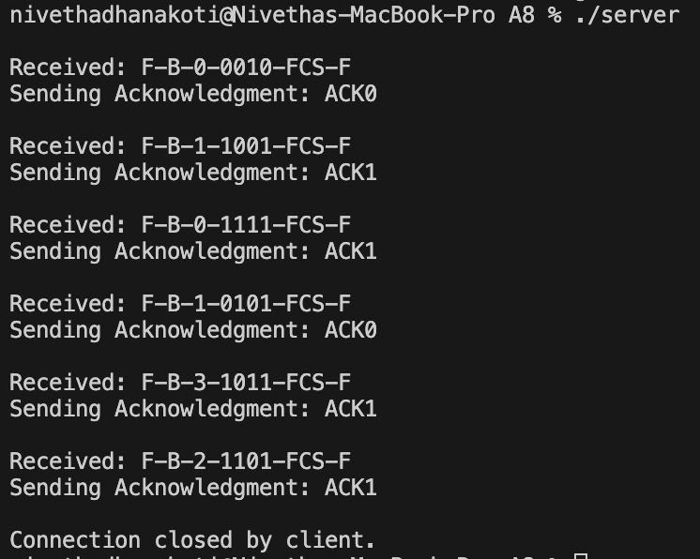

Client Output:
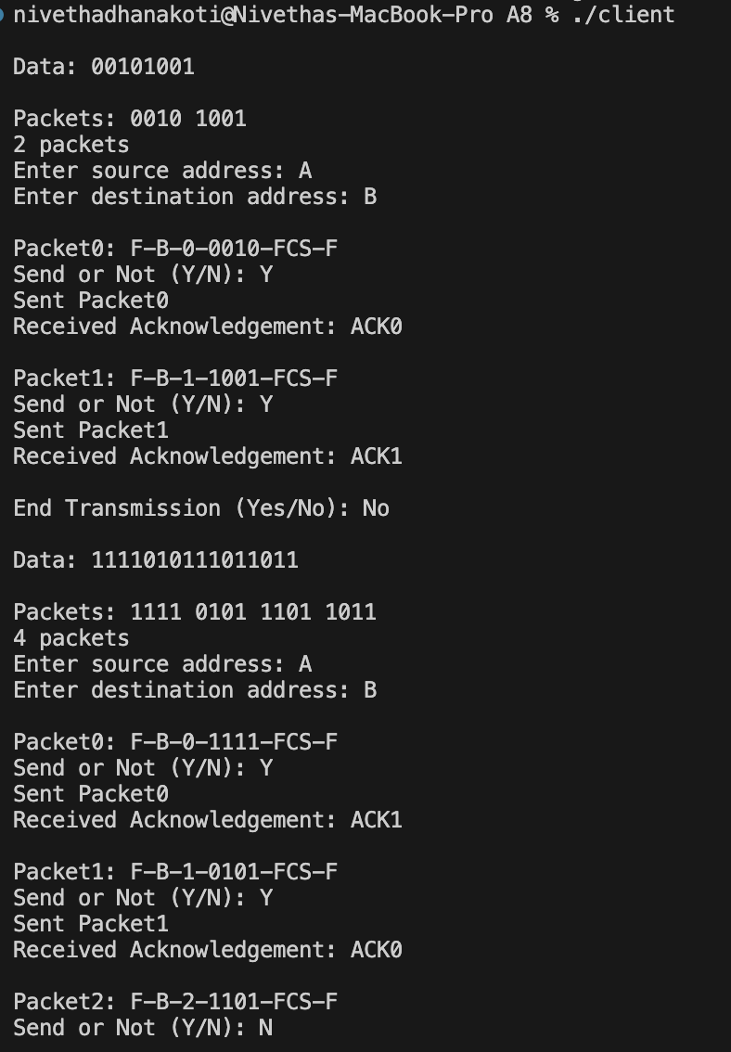
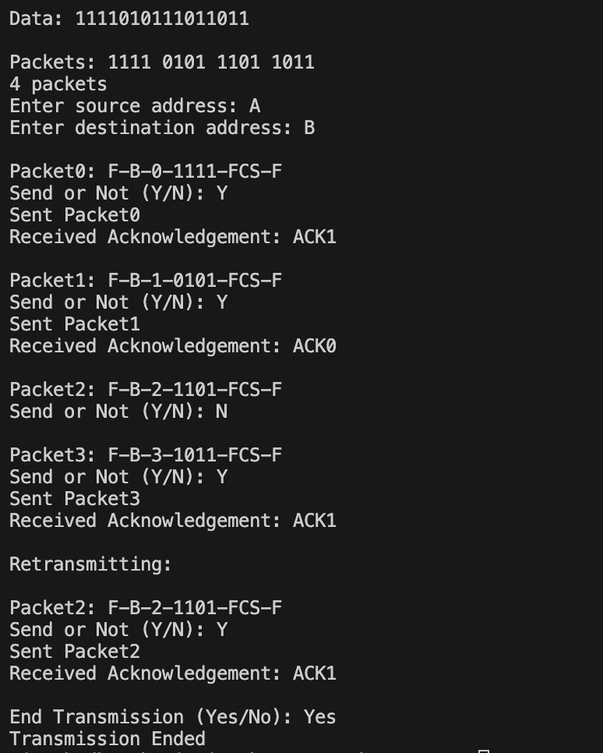

Learning Outcomes:
I have learnt to be proficient in developing an application to simulate flow control technique using socket programming in C

